OBSERVATIONS OF COORBITAL SATELLITES OF SATURN

Emel'yanov N., Varfolomeev M.
Sternberg State Astronomical Institute, Moscow, e-mail : emelia@sai.msu.ru
Institut de Mécanique Céleste et de Calcul des Éphémérides, Paris,
e-mail : emelia@imcce.fr

Abstract. To improve the orbital parameters and masses of coorbital satellites of Saturn, Janus and Epimetheus, new observations of these satellites are necessary. Usually these satellites are observable from the Earth only during the Earth and Sun crossings of Saturn's ring plane which occur once in 14 years. Other ways of observing these satellites were found.

1. Introduction
Saturn coorbital satellites, Janus and Epimetheus, have very interesting dynamics: when viewed in a reference frame rotating at the average mean motion of the satellites, they move on horseshoe-shaped orbits. The complete libration period around the horseshoe is 8.01 years, while the average minimum planetocentric angular separation is 5.6 degrees or about 14900 km. The values of the libration period and the distance of mutual approach are very sensitive to the masses of the satellites, which may be improved from their observations. In other words, new observations of the satellites lead to a more precise determination of their masses and orbital parameters. Unfortunately, Janus and Epimetheus are difficult to be observed being very faint objects and moving very close to the bright A Ring of Saturn. Their magnitudes are 14 and 15 respectively. The only favorable opportunities to obtain the positions of the satellites occur during the ring-plane crossings which take place each 14 years. The events in December 1966, March 1980 and August 1995, Voyager encounters with Saturn in October 1980 and August 1981, as well as Cassini encounters with Saturn in 2004-2006 make the only points on the three periods of libration. That is why observers seek other ways to observe these satellites. The solution found by Nicholson et al. (1992) was to exploit the strong planetary methane and hydrogen absorption at λ=2.0-2.4 μm. Using the infrared camera, the light of the disk may be eliminated. Saturn’s rings, however, remain bright in this spectral region. It is a good idea to use the disk of Saturn to occult or to eclipse the bright ring and to observe the satellites as they pass through superior conjunction. Such a situation occurs only four times during Saturn’s 29-year orbital period. The relative positions of the Earth, Saturn and the Sun restrict the useful windows for observations. The next epoch when these observations are possible arrives in 2013. Our aim is to encourage observers to observe these satellites, planning observations in advance.

2. Time intervals for the proposed observations of coorbital satellites of Saturn.

The time intervals when the edge of the planet occult the external edge of A ring but does not occult yet the orbit of the satellites Janus and Epimetheus are following

2013/11/20 – 2014/11/11,
2020/01/05 – 2020/03/29,
2020/06/19 – 2020/12/30,
2029/05/17 – 2030/04/24,
2033/10/10 – 2033/11/22,
2034/06/27 – 2034/09/03,
2035/01/26 – 2035/06/04.

These dates were found using the following values of the Saturn’s system:
polar radius of Saturn 54364 km (Davies et al., 1996),
external radius of A ring 136770 km (Esposito et al., 1984),
demi-grand axis of satellite orbit 152026.268 km (Nicholson et al.,1992).

Being observed at infrared wavelengths, the planet-ring system will be visible as a single ring interrupted by a gap at its Southern part. Nevertheless, the coorbital satellites Janus and Epimetheus will be visible from the Earth when passing near the gap or near the shaded part of the ring. The duration of each passing is about 30-40 min. The images in Figs. 1-3 show the typical Saturn-ring-satellites configurations during these events (these are examples of how negative images will look like, with the exception of the fact that on the real negative images Saturn will not be visible at all).
For the observations to be scientifically valuable, it is necessary to choose appropriate periods of observations and point the camera on the objects in such a way that some other Saturnian satellite (e.g., Mimas or Enceladus) appears in the view field. It is preferably that the satellites should be observed simultaneously with other satellites. These circumstances may be found using the Natural Satellite Service via internet by the addresses:
http://lnfm1.sai.msu.ru/neb/nss/index.htm
or
http://www.imcce.fr/page.php?nav=fr/ephemerides/generateur/saimirror/nssephe.php
Observational techniques for the observations of such apparent events is described in (Nicholson et al., 1992). The authors of this article made the observations of Janus and Epimetheus in July and August, 1990, with the infrared camera at the Palomar Hale telescope. From the images obtained with this camera they have deduced two astrometric positions of Janus and three of Epimetheus.

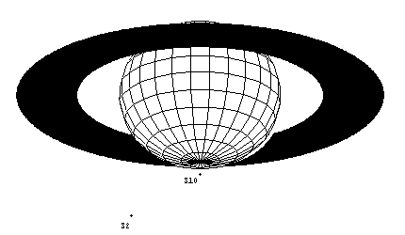Fig. 1. Saturnian system on August 23, 2004, at 4.51222 hours (TT) (S10 − Janus, S2 − Enceladus).

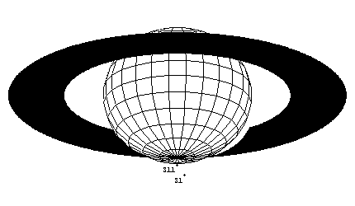Fig. 2. Saturnian system on October 15, 2004, at 5.16722 hours (TT) (S11 − Epimetheus, S1 − Mimas).

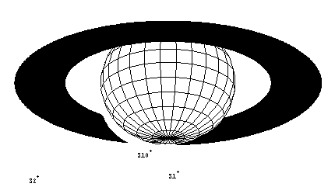Fig. 3. Saturnian system on March 14, 2005, at 0.72472 hours (TT) (S10 − Janus, S1 − Mimas, S2 − Enceladus).

3. Conclusion
The authors hope that this paper will be helpfull to those who wish to observe these events in the Saturnian system. As was said, the occasions when these satellites may be observed are very rare, so every possibility must be used. The next ring plane crossing will take place in September, 2009, while the next possibility to observe Janus and Epimetheus in the superior conjunction will arrive only in November 2013.

References

Davies, M. E.; Abalakin, V. K.; Bursa, M.; Lieske, J. H.;
Morando, B.; Morrison, D.; Seidelmann, P. K.; Sinclair, A. T.;
Yallop, B.; Tjuflin, Y. S. (1996) Report of the IAU/IAG/COSPAR Working Group on Cartographic Coordinates and Rotational Elements of the Planets and Satellites: 1994.
Celestial Mechanics and Dynamical Astronomy. V. 63. P. 127-148.

Esposito, L. W.; Cuzzi, J. N.; Holberg, J. B.; Marouf, E. A.; Tyler, G. L.; Porco, C. C. (1984) Saturn's rings - Structure, dynamics, and particle properties. IN: Saturn. Tucson, AZ, University of Arizona Press, 1984, p. 463-545.

Nicholson P.D., Hamilton D.P., Matthews K., Yoder C.F.: 1992. “New observations of Saturn's coorbital satellites” - Icarus. V. 100, n. 2, p. 464-484.

