Russian – Japanese Lunar Planetary Conference
(RJLPC-2; 29 September 2008, Moscow)
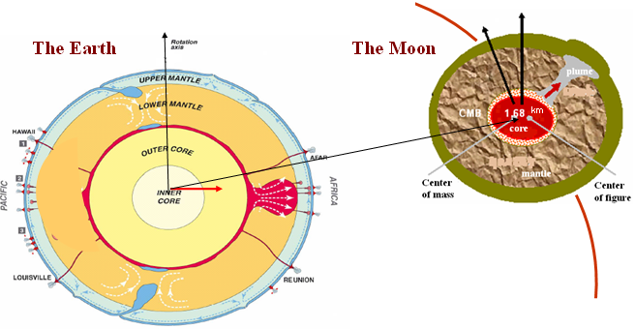

Subject:
Modern projects of studies of the Moon (SELENE, ILOM and oth.) and first scientific results.
First scientific results on colaboration in frame of RFBR-JSPS grant, 2007 – 2009:
“Spin-orbit evolution of the Moon, dynamics of its multypase core in projects SELENE and ILOM”
Geodynamics and planetodynamics.

Place: Moscow State University (MSU), Universitetskii pr-t, 13, Moscow.
Sternberg Astronomical Institute (SAI), conferencezal

The organizer: Sternberg Astronomical Institute, MSU, Laboratory of gravimetry,
Kazan State University, Astronomy department

Organizing committee:
Barkin Yu. (SAI, Moscow),Hanada H. (NAO, Mizusawa),
Petrova N. (KSU, Kazan), Zotov L. (SAI, Moscow)

Program of RJLPC

Session I. The Moon: Kaguya mission
Chair Barkin Yu.V.

10.00 - 10.30 H. Hanada (1), RISE team, RSAT/VRAD team, ILOM team
(1) RISE Project, National Astronomical Observatory, Mizusawa, Oshu, Iwate, Japan
The present status of KAGUYA (SELENE) and ILOM in RISE project

10.30 – 11.00 Matsumoto K. National Astronomical Observatory of Japan
Initial Results of Gravity Experiment by Four-Way Doppler Measurement of Kaguya (SELENE)

11.00 – 11.30 F. Kikuchi (1), Q. Liu (1), N. Petrova (2), K. Matsumoto (1), Y. Ishihara (1), S. Goossens (1), K. Asari (1), S. Tsuruta (1), T. Ishikawa (1), H. Noda (1), H. Hanada (1), T. Iwata (3), N. Namiki (4), N. Kawano (1), and S. Sasaki (1)
(1) National Astronomical Observatory of Japan, (2) Kazan State University, Kazan, Russia,
(3) JAXA, Kanagawa, Japan, (4) Kyushu University, Fukuoka, Japan
Precise phase delay estimation in VRAD mission of Kaguya by same beam and multi frequency VLBI methods

11.30 - 12.00 Coffee break

Session II. The Moon: observations from the Lunar surface
Chair Hanada H.

12.00 – 12.20 Kosuke Heki (Hokkaido University, Japan)
In situ Lunar Orientation Measurement (ILOM)

12.20 – 12.40 Petrova, N. (1); Gusev, A.(1); Hanada, H.(2); Heki, K.(2); Kawano, N.(2)
(1) Kazan State University, Kazan, Russia, (2) National Astronomical Observatory of Japan, Nokio, Japan
Interpretation of the Lunar physical librations for future observations from the Lunar surface.

12.40 – 13.00 Barkin Yu.V. (1); Ferrandiz J.M.(2); Navarro J.F.(2)
(1) Sternberg Astronomical institute, Moscow, Russia; (2) Space Geodezy Laboratory, Alicante University, Spain
Analytical theory of rotational motion of the Moon and dynamical effects caused by liquid core.

13.00 – 13.20 O.L. Kuskov, V.A. Kronrod
(V.I. Vernadsky Institute of Geochemistry and Analytical Chemistry, Russian
Academy of Sciences, Moscow)
A new temperature model of the lunar mantle based on joint inversion of
geochemical and seismic data

13.20 – 15.30 Lunch and excursion around Moscow State University. Vorobievy Gory.

Session III.
Planetary dynamics
Chair Gusev A.

15.30 – 16.00 Heki K. (Hokkaido University, Japan)
Time-varying gravity field of the Earth: gravity signatures of earthquakes, climate change, and orogeny.

16.00 – 16.20 Barkin Yu.V. (Sternberg Astronomical Institute, Moscow, Russia)
About tidal and non-tidal variations of selenopotential coefficients and possible displacements of center of mass of the Moon.

16.20 – 16.40 Koji Matsumoto (NAO, Japan), Yoshihiro Niwa, C.K. Shum, Shin-chan Han, Yuchan Yi, Yu Wang, Hyongki Lee, Alexander Braun
A southern ocean tide model assimilating multiple altimeter data and comparison to tidal observations by GRACE

17.00 -17.30 Cofe breake.

Session IV. Selenodesy and general discussion
Chair Heki K.

17.30 – 19.00
Discussion of cooperation results in the frame of RFBR-JSPS grant, 2007 – 2009: “Spin-orbit evolution of the Moon, dynamics of its multypase core in projects SELENE and ILOM”

