Evidence for Extraterrestrial Biomolecules, Water, and Indigenous Microfossils in Carbonaceous Chondrites

Richard B. Hoover

Buckingham Centre for Astrobiology, University of Buckingham,
Buckingham, MK18 1EG, United Kingdom

Athens State University, Athens, Alabama USA
e-mail: Entogonia@aol.com

ABSTRACT

Carbonaceous chondrites are the most primitive of all known meteorites. These matrix-rich micro-regolith breccias contain carbon and represent a subgroup of stony meteorites that are of great importance to cosmochemistry. These stones are thought to carry an unaltered pristine record of the chemistry of the proto-solar nebula. It has been known since 1834 that carbonaceous chondrites contain water. Although the water was initially believed to be a post arrival contaminant, the minerals in the stones exhibit extensive aqueous alteration and provide strong evidence for low temperature liquid water on the meteorite parent bodies. Over half a century ago, various scientists reported the detection of possible microfossils (organized elements, acritarchs, "blue-green algae" and magnetotactic bacteria) in the CI1 (Alais, Orgueil & Ivuna) and CM2 (Mighei & Murchison) carbonaceous chondrites. The stones were also found to contain a complex suite of life-critical biomolecules (chiral protein amino acids, purine and pyrimidine nucleobases, etc.) and biomolecular fossils such as pristane, phytane and porphyrins (diagenetic breakdown products of chlorophyll), long chain hydrocarbons and kerogen. Many of these biomolecules have never been produced in the laboratory by Miller-Urey of Fischer-Tropsch Synthesis or other abiotic production mechanisms. Nevertheless, these findings were attacked by critics and the post-arrival biological contamination hypothesis became widely accepted by the scientific community and the biological evidence was summarily dismissed.
During the past few decades, several researchers have obtained data that effectively invalidates the post-arrival bio-contamination hypothesis. Carbonaceous chondrites are now known to contain only 3 of the 5 nucleobases essential for life and only 8 (the most stable) of the 20 life-critical protein amino acids which are present in living cell. Stable carbon isotope studies have established that these biomolecules indigenous and extraterrestrial. Living microorganisms could not possibly introduce only a subset of the biomolecules present in DNA, RNA and all proteins. Hence, contamination of these carbonaceous meteorites by recent microbes can be ruled out and the biomolecules are indicative of ancient extraterrestrial microbiological activity. This conclusion is supported by the independent detection in the U.S., U.K. and Russia of intact and recognizable microfossils of filamentous cyanobacteria, acritarchs, hystrichospheres, and diatoms in freshly fractured interior surfaces of meteorites. EDAX nitrogen data for many of these fossils is below the instrumental detection limit (<0.5% atomic) at levels consistent with those found in ancient (Pleistocene to Archaean) microbial remains. Many of these microfossils are permineralized and extinct life forms that are observed to be embedded in the meteorite rock matrix. Therefore, they could not possibly have invaded the stones after the meteorites were observed to fall. The biomolecular data will be discussed and recently obtained FESEM images and EDAX data for embedded microfossils will be presented. The well preserved and clearly recognizable microorganisms in carbonaceous meteorites are interpreted as indigenous remains of prokaryotic and eukaryotic microbiota and direct observational evidence for the existence of Extraterrestrial Life.

BIOGRAPHICAL SKETCH

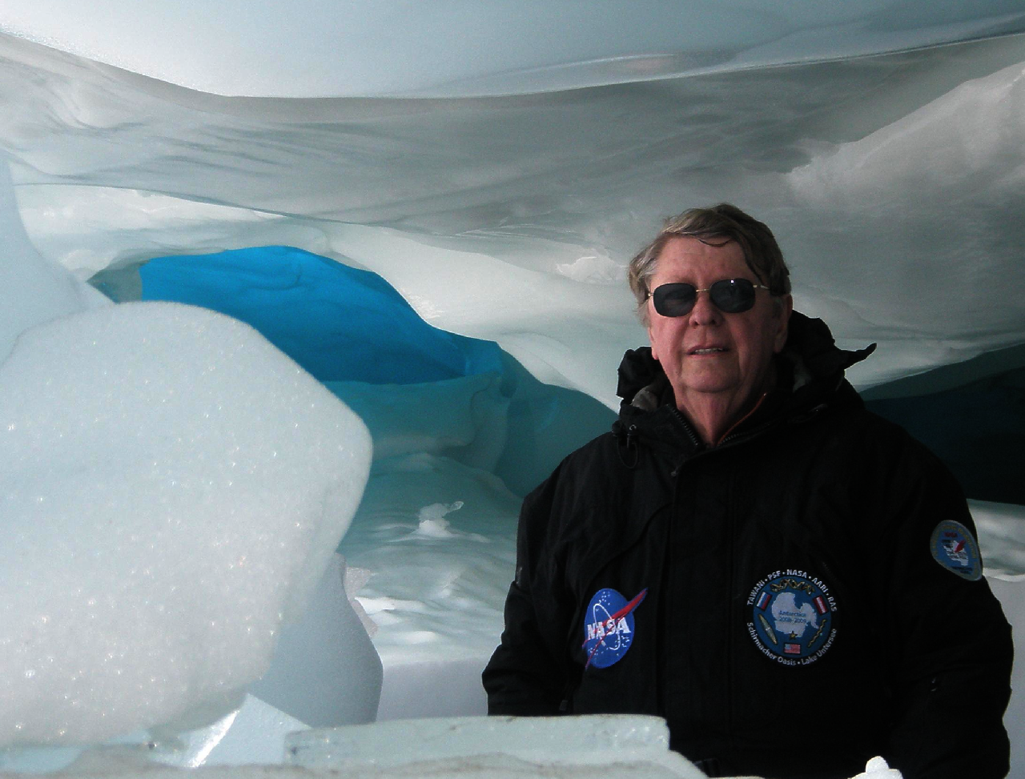 Richard B. Hoover established the Astrobiology Research Group at the NASA/Marshall Space Flight Center in 1998. He is currently Astrobiologist at Athens State University and Visiting Research Professor with the Centre for Astrobiology at the University of Buckingham in the United Kingdom. Richard B. Hoover joined the NASA/Marshall Space Flight Center in 1966. He developed the Grazing Incidence X-Ray Telescope that produced x-ray images of the Sun from America’s first Space Station, SKYLAB and the Multilayer X-Ray Telescope that produced the first High Resolution images of the Sun with Normal Incidence X-Ray Reflecting Mirrors. Hoover was selected NASA Inventor of the Year in 1992 for the Invention of the Water Window Imaging X-Ray Microscope. He is internationally known for his work on diatoms and conducted the Inventory of the diatoms of the Henri Van Heurck Museum at the Invitation of the Royal Society of Zoology of Antwerp, Belgium. Since 1997, his Astrobiology research at NASA/MSFC has concentrated on microorganisms that live in extreme environments and the search for evidence of microfossils in ancient rocks and carbonaceous meteorites. Hoover was Science Team Lead for the Antarctica 2000 Expedition with Apollo Astronaut James A. Lovell (Gemini 7 & 12; Apollo 8 & 13) and Skykab Astronaut Owen K. Garriott (Skylab III, Spacelab 1). This expedition recovered 20 meteorites that are currently housed in the Field Museum in Chicago. Working in collaboration with Dr. Elena V. Pikuta, he emended the description of the important Genus Spirochaeta (Ehrenberg, 1835). He has published two new validated genera (Anaerovirgula and Proteocatella) and ten new species of bacteria and archaea from samples collected during these expeditions. Richard Hoover was elected Fellow National of the Explorers Club for the leading scientific expeditions to some of the planet's most hostile environments. In 2003, Hoover was made and honorary Life Member of the Planetary Studies Foundation for his research on microfossils in carbonaceous meteorites. He has Authored/Edited 40 books and over 300 scientific papers on X-Ray/EUV optics, diatoms, microbial extremophiles, meteorites, and Astrobiology. His research has been featured in films by the National Science Foundation, BBC; The Discovery Channel, The History Channel, National Geographic, National Science Foundation, and NHK Japan Television. Richard B. Hoover was 2001 President of SPIE, the International Society for Optical Engineering. In 2009, he was awarded the SPIE Gold Medal of the Society for his contributions to SPIE and to the science of X-Ray Optics and Astrobiology. On January 29, 2013, Richard Hoover (in collaboration with colleagues from the UK) interviewed eyewitnesses to the Dec. 29, 2012 bolide and observed fall. He collected samples of the Polonnaruwa stones from a paddy fields in Aralangawila, North Central Sri Lanka and obtained FESEM images and EDAX data on diatoms and other ancient microbial remains found embedded in-situ in the stones.

